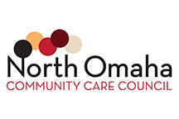

NOCCC Scholarship Program
Essay

Directions: Please answer the following questions below. Please limit your response to no more than 1,000 words (2 pages) single-spaced, 12-point font, with ½ inch margins. Please including page numbers and last name in the header or footer of your document. No handwritten essays will be accepted.

Essay Questions (please answer all questions): 1) Please write a short autobiography including information about what high school you attend, where you grew up, your family, work experience, and community involvement. 2) What is a health problem in your community, in Omaha, or statewide? 3) How will you use your current health major to positively influence this health problem?

